**Experimental Verification of Zipf’s Law, Mandelbrot’s Hypothesis, and Heap’s Law**

**1FIRST AUTHOR’S NAME, 2SECOND AUTHOR’S NAME**

1 Department, College/ University Name, Address, Country

2 (Department, College/ University Name, Address, Country

Email: 1xxxxxx@XXX.com, 2xxxxxx@XXX.com

**Abstract:** The abstract should summarize the content of the paper. Try to keep the abstract below 350 words. Do not make references nor display equations in the abstract. The journal will be printed from the same-sized copy prepared by you. Your manuscript should be printed on A4 paper (21.0 cm x 29.7 cm). It is imperative that the margins and style described below be adhered to carefully. This will enable us to keep uniformity in the final printed copies of the Journal. Please keep in mind that the manuscript you prepare will be photographed and printed as it is received. Readability of copy is of paramount importance.

**Keywords**: About five key words in alphabetical order, separated by comma

1. **INTRODUCTION**

The introduction of the paper should explain the nature of the problem, previous work, purpose, and the contribution of the paper. The contents of each section may be provided to understand easily about the paper.

Compressive loads and more frequent thermal shock than their aircraft counterparts. In addition, many of these TBCs must cope with the contaminates found in lower-grade fuels. The difference between aircraft TBCs and diesel TBCs are often ignored by coating applicators. Thermal barrier coatings can be applied on gas turbines, automotive engines and diesel equipment. The use of TBC on diesel components such as valves, pistons and fire decks insulates the metal substrates from high-temperature oxidation and corrosive environments. As a thermal barrier, it reduces metal temperatures surface are to reduce the heat ﬂux into the piston, to protect the piston from thermal stresses, corrosive attacks due to fuel contaminants and reducing emissions. There are several applications of TBC in SI engines, showing improved performance and emissions. In SI engines, the top surface near the crevice is especially chosen as the place of TBC deposition. Choosing this area also enables to decrease the risk of knocking. The coating thickness has an TBC on diesel components such as valves, pistons and fire decks insulates the metal substrates from high-temperature oxidation and corrosive environments. As a thermal barrier, it reduces metal temperatures (Scientist G), Head of Mechanical Behaviour Group Defence Metallurgical Research Group Labin a direction parallel to the ceramic–bond coat interface (horizontal cracks), which leads to coating delamination. The other typical TBC failure occurs by spalling of the ceramic top coat from the bond coat. Among the various causes of failure of TBC, oxidation and thermal mismatch are identiﬁed as two major factors affecting the life of the coating system. It is observed that the coating surface temperature increase with increasing the thickness in a decreasing rate. As for bond coat surface, increasing coating thickness, the normal stress decreases steadily and the maximum shear stress rises in a decreasing rate. Although diesel TBCs operate at lower temperatures than aircraft engines, they are subjected to much greater compressive loads and more frequent thermal shock than their aircraft counterparts. In addition, many of these TBCs must cope with the contaminates found in lower-grade fuels. The difference between aircraft TBCs and diesel TBCs are often ignored by coating applicators. Thermal barrier coatings can be applied on gas turbines, automotive engines and diesel equipment. The use of TBC on diesel components such as valves, pistons and fire decks insulates compressive loads and more frequent thermal shock than their aircraft counterparts. In addition, many of these TBCs must cope with the contaminates found in lower-grade fuels. The difference between aircraft TBCs and diesel TBCs are often ignored by coating applicators. Thermal barrier coatings can be applied on gas turbines, automotive engines and diesel equipment. The use of TBC on diesel components such as valves, pistons and fire decks insulates the metal substrates from high-temperature oxidation and corrosive environments. As a thermal barrier, it reduces metal temperatures ted in the oil- and water-cooling systems.

The performance of plasma sprayed based YSZ TBCs systems on aluminium alloys is a very important in the automotive industry. In the keeping view of application of aluminum alloys in the automotive industry, the durability of 2024 AA with TBCs systems was studied for high temperature applications. This article investigate the thermal fatigue behaviour of plasma sprayed based YSZ TBCs systems for 2024 aluminium alloy (AA).

1. **DETAILS EXPERIMENTAL**

**2.1. Materials and Procedures**

Compressive loads and more frequent thermal shock than their aircraft counterparts. In addition, many of these TBCs must cope with the contaminates found in lower-grade fuels. The difference between aircraft TBCs and diesel TBCs are often ignored by coating applicators. Thermal barrier coatings can be applied on gas turbines, automotive engines and diesel equipment. The use of TBC on diesel components such as valves, pistons and fire decks insulates the metal substrates from high-temperature oxidation and corrosive environments. As a thermal barrier, it reduces metal temperatures After bond coat, another coat was applied on the surface which is called top coat. Top coat was done of Yttria Stabilized Zirconia (YSZ) by APS. Parameters of top coat parameter are given in **Table 3**.

**Table1: Chemical Composition of 2024 AA**

**Table 2: YSZ top coat Spraying for bond coat**



**Table 3:** **YSZ top coat Spraying Process Parameters for Process Parameters**

**2.2. Thermal Fatigue Test**

The thermal fatigue test was done in a thermal cyclic furnace. The specimens were tested at 6000C highest temperature. Heating and cooling time were kept as 10 minutes. When the samples were cooled to the ambient temperature, they were taken out, dried and put into the high temperature furnace again, repeating the same process. More than 90% of the cracked regions of the surface of TBC systems were adapted as the criterion for the failure of the coating. The weight changes of the samples were measured to a precision of 0.5 mg by an analytical balance. Three number of specimens were tested and average was considered for analysis.

1. **RESULTS AND DISCUSSION**

**3.1. TBC system Composition of**

Microstructure of TBCoated alluminium alloys after thermal cycling till failure is shown in Fig. 1 (a and b). The failure of TBC coated surface on aluminium alloys under thermal fatigue conditions was found be in a cracking mode, which induces from coated compressive loads and more frequent thermal shock than their aircraft counterparts. In addition, many of these TBCs must cope with the contaminates found in lower-grade fuels. The difference between aircraft TBCs and diesel TBCs are often ignored by coating applicators. Thermal barrier coatings can be applied on gas turbines, automotive engines and diesel equipment. The use of TBC on diesel components such as valves, pistons and fire decks insulates the metal substrates from high-temperature oxidation and corrosive environments. As a thermal barrier, it reduces metal temperatures as well as bond coat. The micro-columnar grains encircled in **Fig.2.** was observed, which were solidified from the melted fraction of YSZ top coat powder.

**3.2. Thermal Fatigue behaviours of TBCs systems**

Square specimen were selected to consider the effect in practical application of thermal barrier coating (TBC) system, such as edges and corners in internal combustion (IC) engine piston. It can be seen from Fig. 1 compressive loads and more frequent thermal shock than their aircraft counterparts. In addition, many of these TBCs must cope with the contaminates found in lower-grade fuels. The difference between aircraft TBCs and diesel TBCs are often ignored by coating applicators. Thermal barrier coatings can be applied on gas turbines, automotive engines and diesel equipment. The use of TBC on diesel components such as valves, pistons and fire decks insulates the metal substrates from high-temperature oxidation and corrosive environments. As a thermal barrier, it reduces metal temperatures not occur. After 52 cycles, gradual weight loss was observed indicating thermal degradation of coated specimens. After 97 cycles, the sudden weight loss of samples was observed, which implied the coating damage via the cracking mode.

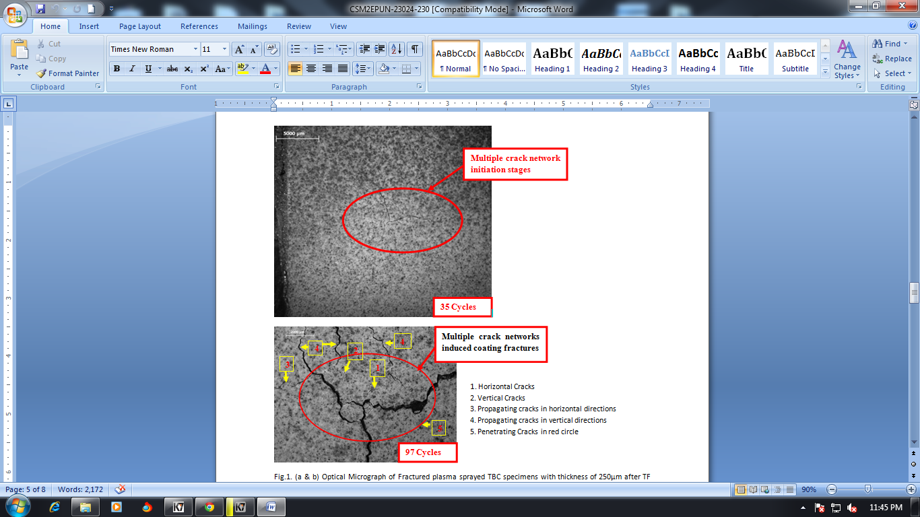

**Fig.1. (a & b) Optical Micrograph of Fractured plasma sprayed TBC specimens with thickness of 250µm after TF testing**

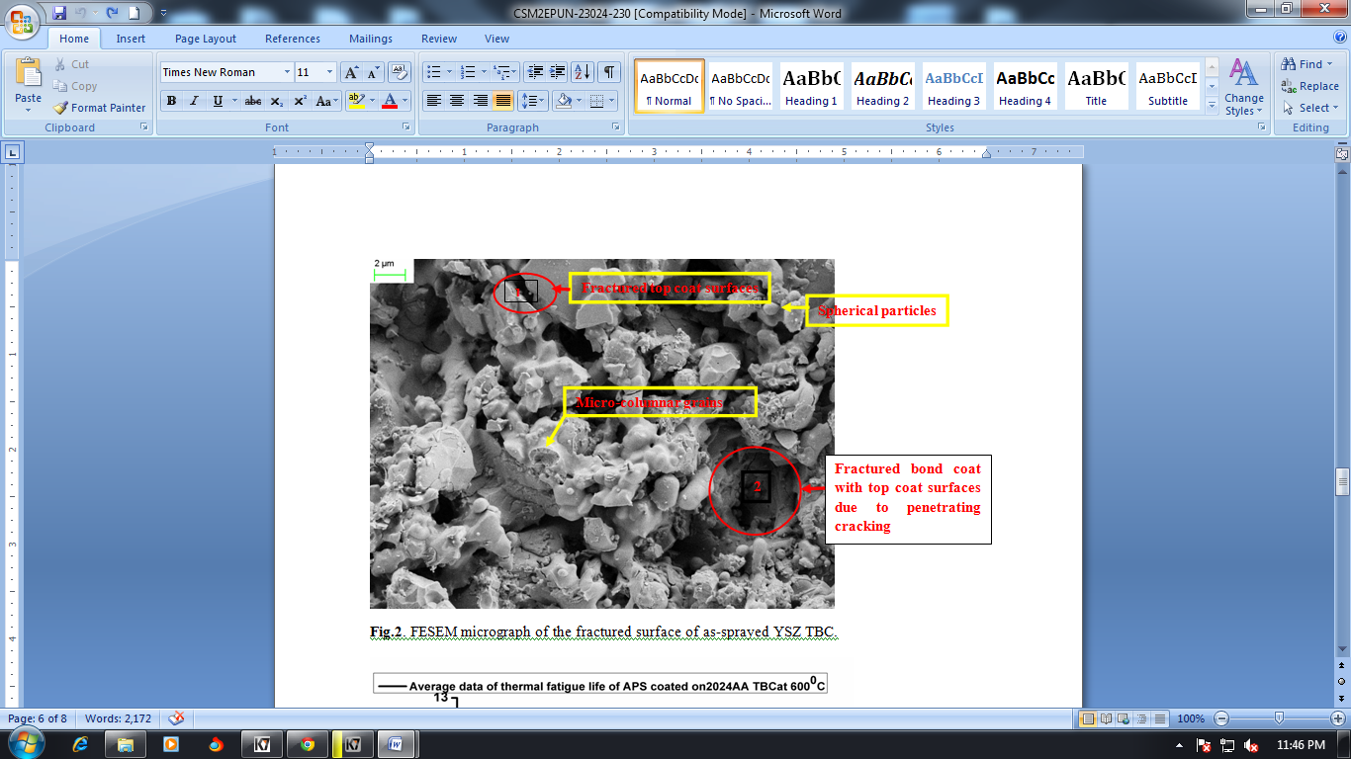

**Fig.2. FESEM micrograph of the fractured surface of as-sprayed YSZ TBC.**

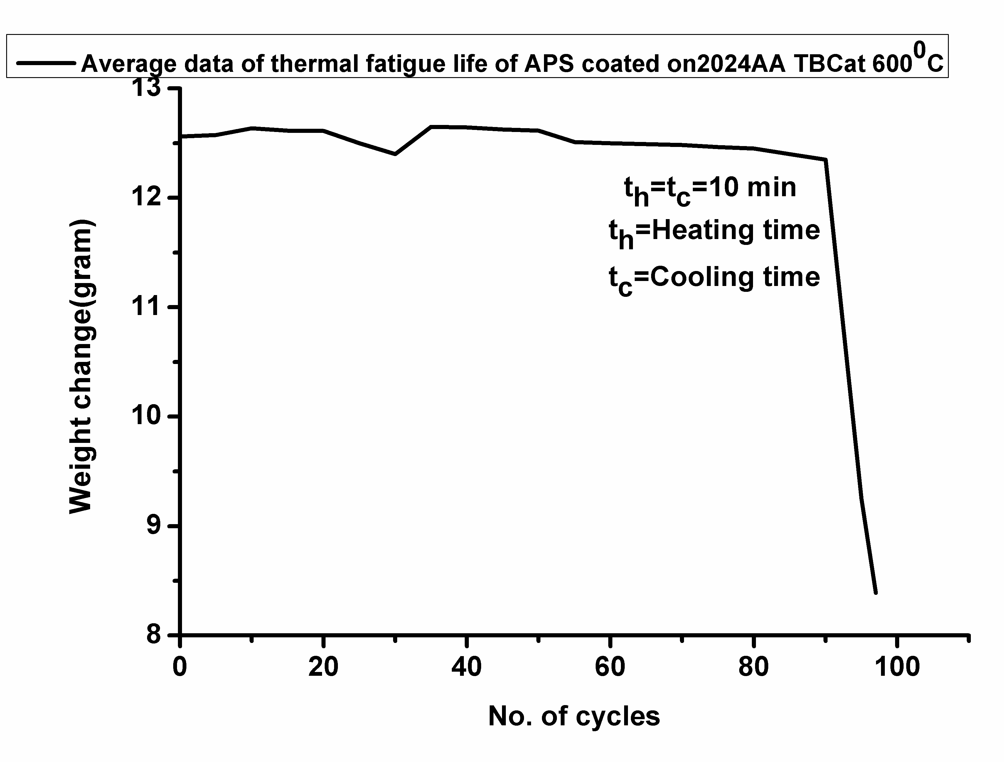

**Fig.3. Weight Change as a function of cycle number YSZ TBCs during thermal fatigue testing.**

**CONCLUSIONS**

Thermal fatigue behavior of plasma sprayed YSZ TBC system on 2024 AA was studied and major conclusions are as follows:

1. In all cases, the initial cracks were initiated at the edge/corner of the square specimens.
2. The failure of YSZ TBCs systems on 2024AA were observed due to the multiple cracks mode only. The results show four types of cracks formed in TBCs systems on 2024 AA, i.e., vertical cracks, horizontal crack, propagating crack, and penetrating crack [16]. In this article, vertical cracks and propagating cracks (or horizontal crack) emerged in YSZ based TBCs systems for 2024AA. The penetrating vertical cracks started penetrate from top coat to the substrate surface at 6000C.

**ACKNOWLEDGMENTS**

TBC on diesel components such as valves, pistons and fire decks insulates the metal substrates from high-temperature oxidation and corrosive environments. As a thermal barrier, it reduces metal temperatures (Scientist G), Head of Mechanical Behaviour Group Defence Metallurgical Research Group Lab, pistons and fire decks insulates the metal substrates from high-temperature oxidation and corrosive environments. As a thermal barrier, it reduces metal temperatures (Scientist G), Head of Mechanical Behaviour Group Defence Metallurgical Research Group Lab (DMRL, Hyderabad) for their cooperation.

**REFERENCES**

1. [C.R.C. Lima](http://www.sciencedirect.com/science/article/pii/S0257897206013120), [J.M. Guilemany](http://www.sciencedirect.com/science/article/pii/S0257897206013120), “Adhesion improvements of Thermal Barrier Coatings with HVOF thermally sprayed bond coats”, [Surface and Coatings Technology](http://www.sciencedirect.com/science/journal/02578972), vol.201,no.8,pp.4694–4701,15 January 2007,.
2. Esfahanian, A. Javaheri, and M. Ghaffarpour, “[Thermal analysis of an SI engine piston using different combustion boundary condition treatments](http://www.sciencedirect.com/science/article/pii/S1359431105001523)”, Applied Thermal Engineering,vol.26,p Esfahanian, A. Javaheri, and M. Ghaffarpour, “[Thermal analysis of an SI engine piston using different combustion boundary condition treatments](http://www.sciencedirect.com/science/article/pii/S1359431105001523)”, Applied Thermal Engineering,vol.26,pp.277-287,2006.”, [Surface and Coatings Technology](http://www.sciencedirect.com/science/journal/02578972),vol. 203, pp. 91-98, 2008.
3. Anna Gilbert, Esfahanian, A. Javaheri, and M. Ghaffarpour, “[Thermal analysis of an SI engine piston using different combustion boundary condition treatments](http://www.sciencedirect.com/science/article/pii/S1359431105001523)”, Applied Thermal Engineering,vol.26,pp.277-287,2006., [Surface and Coatings Technology](http://www.sciencedirect.com/science/journal/02578972),vol..202,pp.2152-2161,2008.
4. T. Hejwowski, and A. Weronski, “[The effect of thermal barrier coatings on diesel engine performance](http://www.sciencedirect.com/science/article/pii/S0042207X01004523)”, Vacuum,vol.65, pp.427-432, 2002.
5. E. Buyukkaya, “[Thermal analysis of functionally graded coating Al-Si alloy and steel pistons](http://www.sciencedirect.com/science/article/pii/S0257897208000807)”, [Surface and Coatings Technology](http://www.sciencedirect.com/science/journal/02578972),vol.202,pp. 3856-3865, 2008.
6. E. Esfahanian, A. Javaheri, and M. Ghaffarpour, “[Thermal analysis of an SI engine piston using different combustion boundary condition treatments](http://www.sciencedirect.com/science/article/pii/S1359431105001523)”, Applied Thermal Engineering,vol.26,pp.277-287,2006.,pp.398-402,2007.
7. M. Cerit, V. Ayhan, A. Parlak, and H. Yasar, “[Thermal analysis of a partially ceramic coated piston: Effect on cold start HC emission in a spark ignition engine](http://www.sciencedirect.com/science/article/pii/S1359431110004023)”, Applied Thermal Engineering,vol. 31,no. 2 –3,pp.336-341,2011.
8. Michael Anderson Marr, “An Investigation of Metal and Ceramic Thermal Barrier Coatings in a Spark-Ignition Engine”, M.S thesis, Mechanical and Industrial Engineering, University of Toronto, 2009.
9. V. Esfahanian, A. Javaheri, and M. Ghaffarpour, “[Thermal analysis of an SI engine piston using different combustion boundary condition treatments](http://www.sciencedirect.com/science/article/pii/S1359431105001523)”, Applied Thermal Engineering,vol.26,pp.277-287,2006.
10. Muhammet Cerit, “Thermo mechanical analysis of a partially ceramic coated piston used in an SI engine”, Surface & Coatings Technology,vol.205, pp. 3499-3505,2011.
11. Daniel W Parker, “Thermal barrier coatings for gas turbines, automotive engines and diesel equipment”, Materials & Design, Vol. 13,no. 6,pp. 345-351,1992.
12. H. Jamali, R. Mozafarinia, R. Shoja Razavi, and R. Ahmadi-Pidani, “Fabrication and Evaluation of Plasma-Sprayed Nanostructured and Conventional YSZ Thermal Barrier Coatings”, Ceramic International,vol.38, pp.6805-6712,2012.
13. R. Ahmadi-Pidani, R. Shoja-Razavi, R. Mozafarinia, and H. Jamali, “Improving the thermal shock resistance of plasma sprayed CYSZ thermal barrier coatings by laser surface modification”, Optics and Lasers in Engineering, vol.50, pp.780–786,2012.
14. C. Giolli, A. Scrivani, G. Rizzi, F. Borgioli, G. Bolelli, and L. Lusvarghi, “Failure mechanism for thermal fatigue of thermal barrier coating systems”, Journal of Thermal Spray Technology,vol.18,pp.223–230,2009.
15. C. Zhou, Q. Zhang, and Y. Li, “Thermal shock behavior of nanostructured and microstructured thermal barrier coatings on a Fe-based alloy”, Surface & Coatings Technology,vol.217,pp. 70–75,2013.

★★★